Relevant Anatomy

.
- Neck shaft angle 130°

- 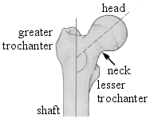
- 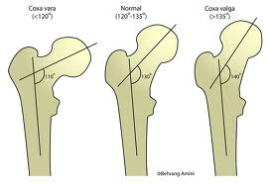

- Anteversion 10°

- 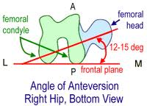

- Thickness of the articular cartilage: 4mm superiorly and
- 3mm at the periphery.

- Capsule extends up to: Intertrochanteric line anterior aspect of the neck
- Half way through intertrochanteric crest

- 3 Capsular ligaments
Iliofemoral [Anterior capsular thickening] Y shaped [Bigallow’s ligament]
Pubofemoral ligament [Medial}
Ischiofemoral [Posterior ligament]

- 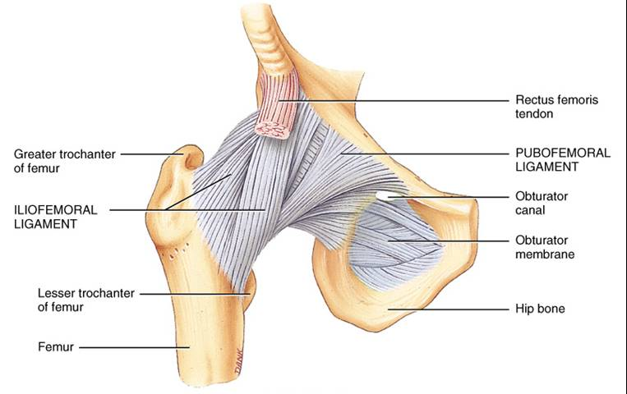
- 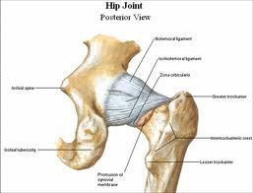
- Synovial
Retinaculum of Weitbrecht: synovial folds of the hip joint also called retinacula of Weitbrecht and deals with the significance of these folds for the blood supply of the proximal end of the femur.
3 retinacula of Weitbrecht:
a. Retinaculum anterius passes along the anterior surface of the neck originating from linea intertrochanteric toward the femoral head.
b. Retinaculum mediale [Amantini's fold] passes from the lesser trochanter to fovea capitis femoris along the medial surface of the neck.
- .

Blood Circulation to the proximal femur

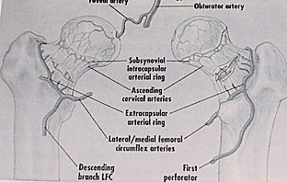
MCFA- Main supply
2 groups of vessels
a. Lateral epiphyseal artery [80%]
b. Superior metaphyseal Artery

LCFA Gives inferior Metaphyseal artery

Obutrator Artery Medial Epiphyseal artery [through
ligamentum teres]

Recent dynamic study: In a minimal displaced fracture, there is 60% decrease in circulation.
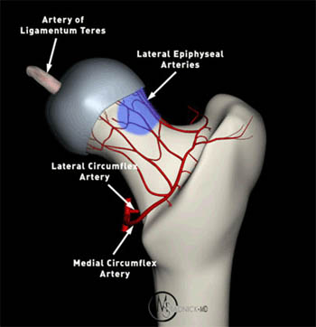

Trabecular System
- Calcar femorale: dense vertical plate of bone that originates from the posteromedial portion of the femoral shaft radiates superiorly
- Primary compression/Tension and II trabeculae
- Wards triangle;

- Babcocks triangle
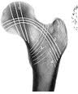
- Primary compression trabeculae

- Tension trabeculae

- Secondary trabeculae

- Ward’s Triangle

- Babcocok’s Triangle

1
5 4
2
3
2

3

1

Assessment of Osteoporosis by Singh’s Grading

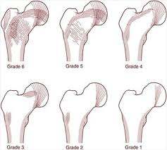
Ossification Of Femur
- The centre of the future shaft II IUM
- 9 th M at birth [distal femur secondary ossification]
- The centre for the head appears in the first year
- The great trochanter at three year
- The small trochanter at 12 year
- Fusion of the head epiphysis with the neck, which has become longer, occurs at about 18 year
- The bony lower end remains distinct until 23 year

