FRACTURE NECK OF FEMUR

Epidemiology

More in Caucasians than blacks;
Women twice than men
Age [doubling with each decade],
Osteoporosis: 1S.D = 2.33
Habitus: Urban dweller, smoking, excessive alcohol, less physical activity
[osteoporosis]
Non-obese more than obese
Co-morbidities: dementia, CVS
2% May have osteomalacia [JBJS 69B: 388]
Hip protector: reduces fracture incidence by 50%

Biomechanics
Mechanism: 90% Fall from a standing position
10% Trauma [young with high velocity injury]

Holloway: 24% had increasing pain in the hip before the fall

Classification

Pawell’s Classification
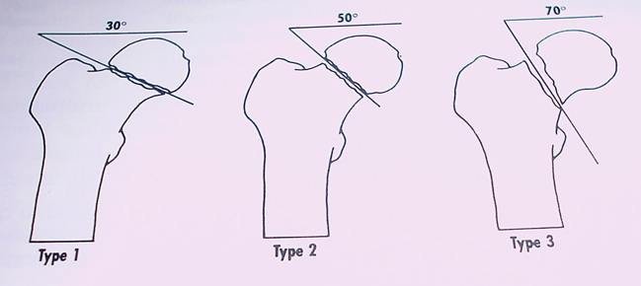
Type III is unstable.

Disadvantage of this classification: Appearance depends on rotation of the hip.

Garden’s classification

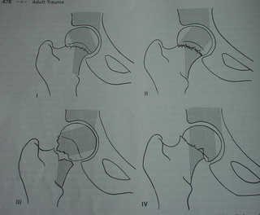
I Incomplete trabeculae fracture
Valgus impaction
II Complete trabeculae fracture; undisplaced
Trabeculae aligned
III Complete, displaced
Trabeculae malaligned with acetabular and neck
IV Complete trabeculae fracture, displaced
Realignment of trabeculae

Garden Nonunion Avascular necrosis

I 1% 15%
II
III 30 26%
IV 34% 27% JBJS 58B:2

Assessment

1. Why fall? Black out [TIA]
Cardiac [Arrhythmia]
Severe osteoporosis
2. Look for the comorbidities
3. Demented: Rest home or family or Mobile active elderly
4. If transfer is delayed: Skin problem
Dehydration

5. Living situation and mobility
6. Legal guardian : Power of attorney

7. Clinical
1. Routine X ray: Pelvis with both hips; AP and lateral of affected
Repeat X ray with hip in 15°
2. If not fracture: Admit and mobilise
If mobilization not achieved, re X ray after 48 hours
Or MRI [24 hours] or Bone scan [48 hours]
2. Bloods
3. ECG
4. IV drip
5. Catheter
6. Femoral nerve block

New Mobility Score

Scores give significant prediction: Both Mobility and mental score gives high predictive value. The mobility score had a greater predictive value and is easier to use.
Parker. JBJS 75 797

Mobility | No difficulty | With an aid | With help from another person | Not at all
About to get about the house | 3 | 2 | 1 | 0
Able to get out of the house | 3 | 2 | 1 | 0
Able to go shopping | 3 | 2 | 1 | 0

Management

Decision making CORR Bray CORR 339: 220-31

- Age: <65 IF
- Vitality: Preinjury functional status
- Garden’s type
- Level [Neck/Intertrochanteric/subtrochanteric]
- Angle of fracture line [Powel’s]
- Medical co-morbidities: Cardiac, Parkinsons, Stroke
- Osteoporosis
6. Posterior comminution of the neck

Surgeon controlled factors
1.Type of surgery
2. Timing of surgery
3. Quality of reduction
4. Aspiration hematoma
5. Post-op rehabilitation and physio

#NOF
Garden I & II
Garden III & IV
<70
>70
ORIF or THR
Mobile: THR
Hemiarthroplasty
Mobile: ORIF
Very osteoporotic
>70, comorbidities
Hemi
Young: always urgent
Fix: close or open

ORIF: Cannulated screws or DHS
THR: Through a direct lateral approach
Hemiarthroplasty: Cemented

Timing of fixation
Fracture type Patient comorbidities Timing
Non displaced Healthy 24 hrs
Displaced Healthy and young Urgent
Any fracture Unhealthy Delay 48 hours; get
Medical Clearance
10% of fracture requires delaying surgery to improve their medical state.
Zuckerman: delay more than 48 hours: doubles the 1 year mortality risk. But there are some reports indicating that delay does not increase mortality. However, recent study proved that the mortality rises after 4 days.[Nottingham study 2005; 87B:483].

Can an impacted fracture neck femur treated non-operatively
Non-op: [Crawford] successfully managed non-operative
Bentley: Non-op: 16% of stable fractures Displace.
Present thinking: Non-op: historical interest only.
The low morbidity of percutaneous cannulated screw fixation of these fractures is such that the benefits of surgical stabilization far outweigh the risks.

In a displaced fracture [Garden III and IV]
When to internally fix and when to perform THR?
<65 years: Urgent ORIF should be the first line of treatment in Young patients despite the incidence of 40% of AVN in Garden stage IV. A successful ORIF, results are superior to THR or Hemi.

65-75 years more controversy
Reoperation after internal fixation was 35% at 2 years. In more active patients between 65 and 75 years of age, ORIF may well be acceptable because of the advantages of retaining the patient's own hip in this group[PJ Gregg: JBJS 76B: 891].

>75 years
Active and mobile: THR
Inactive: Hemiarthroplasty

How to reduce a fracture?
In a fracture table, traction and abduction to 20 degrees in external rotation, then adduction to neutral, 30 degrees and internal rotation to reduce the fracture.

Type of fixation
a.Triflange with/without side plate: should not be used for neck fractures as there is
high incidence of AVN
b.Multiple cannulated screw: Parallel, 8-10 mm short of the joint
2 superior and one inferior
One pin in the inferior and one close to posterior
Parallel in AP and Lateral
Entry above lesser trochanter

c.DHS Vs Cannulated screw Equally effective
Avoid: Posterior and superior of the head to avoid AVN

Optimal Reduction
Ideal AP: 130°-150° valgus
Lateral: 0-15° anteversion

Acceptable
Up to +/-15° of valgus;
+/-10° of anterior or posterior angulation

Avoid
Varus and retroversion

Always THR
1. Mobile elderly with displaced fracture neck femur
2. Contralateral hip: preexisting disease
3. Fracture neck with arthritis (OA, Rh, Pagets, AVN)
5. Metastatic disease in the ipsilateral acetabulum with fracture neck
6. Failed internal fixation or endoprosthesis

Ipsilateral neck and shaft fracture

Priority is for the neck
Patient on the fracture table boot traction
If alignment is not good
Schanz pin in the shaft femur
Rarely requires open reduction
Then fix femur [Retrograde]
Other Options: long Richards

In open fracture: Ex fix and delayed retrograde is the safest

Complications
1. Medical
Mortality at 1 yr 15-30%
DVT 40-80%
PE 4-10%
Note: DVT rate in operated within 24 hrs is 10% and over 2 days 50%
Routine DVT prophylaxis is indicated

2. AVN
- Incidence is higher with grade of Garden: 30% with III and IV
b. Symptoms depend on functional demand: More
symptomatic in younger patients.
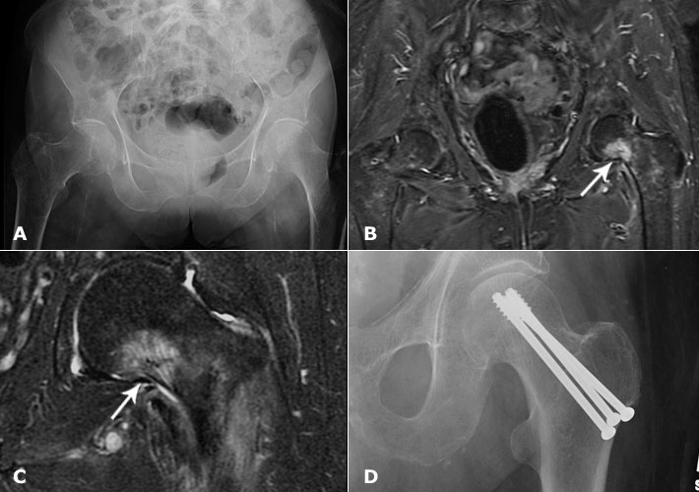
c. Patient with normal bone stock has higher risk
d. MRI: early detection when implants used are pure
titanium or nonmetals. Therefore it is not practical
e. Once diagnosed and symptomatic: THR

3. Failure of fixation
Suspect: Patient complaining pain in the groin or buttock
Critical factor: is lack of stable reduction

Inappropriate patient for fixation (Osteoporosis)
Recognised: Halo around fixation
Migration of fixation
Cut through of fixation in to the joint

Fixation failure: Young – Refix the fracture; In old - THR

3. Delayed diagnosis
13.5% diagnosis is delayed.
Of this half: failed to seek medical advice.
15% GPs failed to diagnosis as patient could straight leg.
36% diagnosis was missed in the hospital.
Causes in the hospital: Poor quality X rays,
X rays misinterpreted.
Only 9 of 154, fracture was invisible in the first X ray.
When in doubt?
One T1 sequence on MRI black line
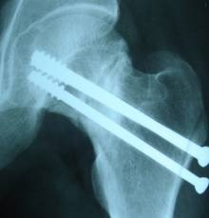

4. Nonunion: Nonunion: no union > 12 months
Cause:
AVN
Posterior commination
Unstable fixation

X ray and tomogram
Treatment:
Young: Refix with bone graft or muscle pedicle graft + valgus osteotomy [Marti good results]
Old: Painful NU = THR

Poor Prognosis
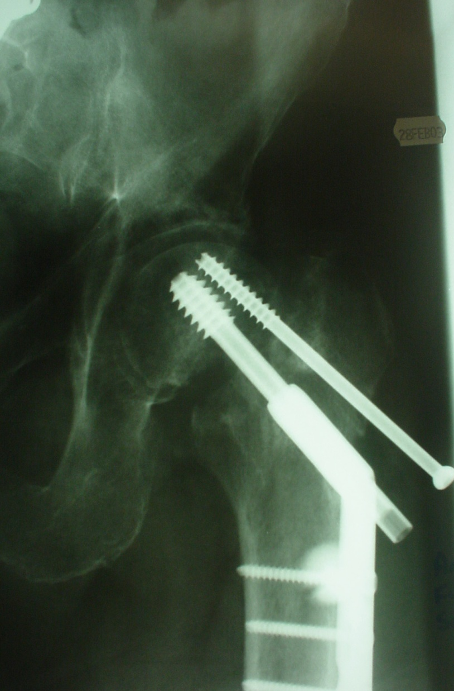
Varus angulation of head 30°
Cranial displacement by 20 mm
Small head fragment (<15mm)
Comminution of the calcar
Watch for backing out >10 mm = watch out for failure
Any one of above sign failure is 50% within 3 months.

Outcome
1. NOF. 85A: Sept. Bhandari
Nine trials, which included a total of 1162 patients
In comparison with internal fixation, arthroplasty for the treatment of a displaced femoral neck fracture significantly reduces the risk of revision surgery
There is greater infection rates, blood loss, and operative time. Marginal increase in early mortality rates.

2. Swedish: 2005;87A:1680-1688
102 patients [Gardens III and IV] of mean age 80 years, with an acute displaced fracture of the femoral neck. They were randomly placed into two groups, treated either by internal fixation (IF) with two cannulated screws or total hip replacement (THR). The failure rate after 2 yrs; IF 36% and THR 4%

3. Mayo Clinic study
The overall mortality rate within thirty days after hip arthroplasty for the treatment of an acute fracture was 2.4%.
The thirty-day mortality rate was significantly higher for patients who had received a cemented implant, female patients [3 Vs 1.8], elderly patients, patients with cardiorespiratory comorbidities, and patients with intertrochanteric fractures [5% Vs 2%].

.

