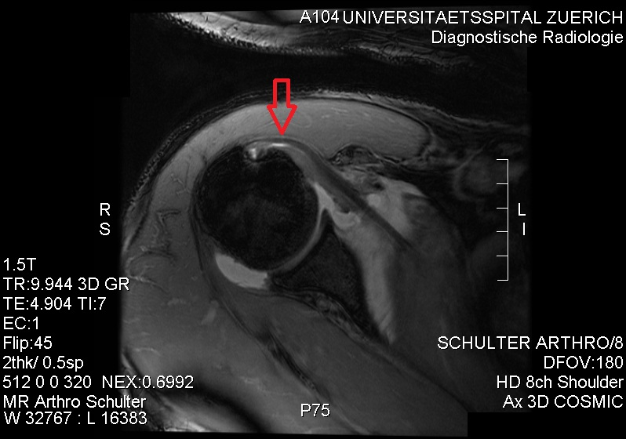
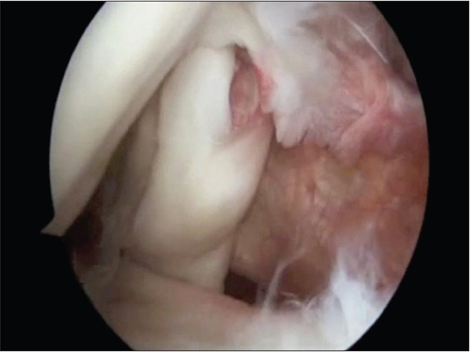
? Diagnosis
Diagnosis PARTIAL TEAR OF THE SUBSCAPULARIS
Gerber and Krushell reported the clinical features of 16 patients with an isolated subscapularis rupture and described the lift-off test [J Bone Joint Surg Br. 1991; 73:389]. The majority of tears involved the superior two-thirds of the tendon and was associated with concomitant pathological changes of the long head of the biceps tendon.
Szabo reported [Journal of Bone and Joint Surgery; Apr 2005; 87, 4, 725]: Of the 84 shoulders,: 83.3% were in men, 77% were on the dominant side, and the average age of the patients at the time of surgery was 53.2 years. 67.9% the patient identified a specific traumatic episode that had initiated the symptoms, and in twenty-seven cases (32.1 %) the patient did not recall a traumatic episode. In eighteen cases (21.4%), the patient reported a shoulder dislocation at the time of injury.
Dierkman [Int J Shoulder Surg. 2013 Jul-Sep; 7(3): 83–90.] presented the first reported series of patients with very specific subscapularis tendinopathy. The primary intent of this study is to raise awareness of these non-insertional lesions which likely to represent early degeneration within the spectrum of subscapularis pathology. Little has been published regarding the degenerative process leading to subscapularis tears, but it seems reasonable to assume a similar degenerative process as in the supraspinatus is responsible. Degeneration the tendon may cause tear at the footprint [insertional tear] or noninsertional tear [Conrad lesion].
Burkhart [Arthroscopy. 2002;18:454–63]initially reported their results on arthroscopic treatment of subscapularis tears in 25 patients, eight of whom had isolated repairs. Good to excellent results were achieved in 92% of patients.
It is unclear whether meaningful comparisons between our results of noninsertional tear and those of others can be made as previous reports on subscapularis repairs involved tendon footprint detachment from the lesser tuberosity. Supraspinatus tendon disease with footprint disruption represents more advanced tendon degeneration and accompanying shoulder dysfunction in comparison to intratendinous tears [J Shoulder Elbow Surg. 2010;19:837–46].
It seems likely that the functional results following side-to-side repair of non-insertional split tears would, at a minimum, reveal results equal or superior to those repairs involving tendon detachment.
We feel, it is more likely that treatment of isolated non-insertional tendinopathy would lead to improved functional results compared with repair of footprint avulsions for two reasons. First, pre-operative functional scores of patients with intra-articular subscapularis tendinopathy with an intact footprint would be expected to be higher than more advanced tears involving disruption of the footprint, which would likely lead to higher post-operative scores as well.
Secondly, side-to-side repair of intratendinous tears is performed and may prevent further tear propagation involving the footprint – and as such, these less advanced tears would be expected to have better outcomes.
ETIOLOGY
Asymptomatic shoulder abnormalities were found in 96% of the subjects. The most common were subacromial-subdeltoid bursal thickening, acromioclavicular joint osteoarthritis, and supraspinatus tendinosis. Ultrasound findings should be interpreted closely with clinical findings to determine the cause of symptoms [AJR Am J Roentgenol. 2011 Oct;197(4):W713-9]

In A cohort of 393 subjects with an atraumatic symptomatic full-thickness [J Bone Joint Surg Am. 2014 May 21;96(10):793-800]: The median age was 61 years. and the dominant shoulder was involved in 69% of the patients. The duration of symptoms was less than one month for 8% of the patients, one to three months for 22%, four to six months for 20%, seven to twelve months for 15%, and more than a year for 36%. The tear involved only the supraspinatus in 72% of the patients; the supraspinatus and infraspinatus, with or without the teres minor, in 21%; and only the subscapularis in 7%. Humeral head migration was noted in 16%. Tendon retraction was minimal in 48%, midhumeral in 34%, glenohumeral in 13%, and to the glenoid in 5%. Anatomic features defining the severity of atraumatic rotator cuff tears are not associated with the pain level.
Previous studies have identified intratendinous degeneration as a factor in subscapularis tearing. Sakurai [J Shoulder Elbow Surg. 1998;7:510–5.] showed degeneration of the subscapularis tendon in 17 of 46 cadaveric shoulders.
I The degeneration was always articular-sided tearing on the superior (leading) edge of the tendon, which was also seen in our patients. Sano et al. showed similar results, with articular-sided degeneration being more prominent than bursal-sided tearing [J Shoulder Elbow Surg. 1999;8:574–9 and Int J Shoulder Surg. 2013 Jul-Sep; 7(3): 83–90.] Despite these findings, there were no comments on lesions without footprint involvement. These studies do emphasize the degree that age-related degeneration plays in subscapularis tears and the histopathologic findings and support degeneration as a likely etiology. All pathology occurred on the articular side of the tendon and in addition, all patients’ in Dierkman series tears showed substantial intrasubstance involvement with granulation tissue and degeneration.
II Impingement: as a cause of tear reported by Gerber [J Shoulder Elbow Surg. 2000;9:483–90]. They documented increased contact and tensile stress on the deep portion of the subscapularis in a position of forward elevation and internal rotation as the tendon is compressed between the lesser tuberosity and the glenoid/labrum.
It has been suspected [nt J Shoulder Surg. 2013 Jul-Sep; 7(3): 83–90] these lesions represent progressive degeneration in the spectrum of subscapularis tears and has bee classified into three type of subscapularis tendiopathy. Unfortunately, until natural history studies are not available. Advancing from Type I to III represents progressive tendinopathy in the leading edge of the tendon
Conrad classification of non-insertional tendinopathy of the subscapularis
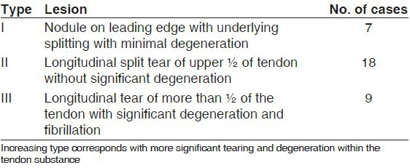

It is possible that there may have been associated footprint involvement not seen on MRI or during arthroscopy. These lesions may have been poorly visualized and inadvertently missed as this is a commonly reported issue regarding arthroscopic evaluation and treatment of subscapularis tears [Arthroscopy. 2008;24:1381–9].
Sano et al. and Uhthoff [Orthop Clin North Am. 1997;28:31–41] the degeneration of the tendon can lead to weakening of the insertion point and eventual mechanical failure of the tendon itself.
No detrimental effects were seen in recent study [nt J Shoulder Surg. 2013 Jul-Sep; 7(3): 83–90] following side to side suture repair of the subscapularis lesion, suggesting it is safe and it may potentially alleviate continued degeneration into a full-thickness tear.

The present study demonstrates that reversal of a positive lift-off test and belly-press test is largely related to the degree of fatty degeneration of the subscapularis muscle. This finding is logical, as abnormal muscle will not contract normally. Currently, when treating patients who have advanced fatty infiltration of the subscapularis, we perform a pectoralis major tendon tra nsfer to better restore internal rotation strength [J Bone Joint Surg Am. 2000;82:372-82.]
CONCLUSION
Need increase awareness of non-insertional subscapularis tendinopathy by describing the Conrad lesion, presenting a classification of non-insertional pathology of the subscapularis, and reporting our early experience in treating this spectrum of tendinopathy.
Results of the present study show that debridement and repair of longitudinal split tears of the subscapularis can result in healing of the subscapularis tendon and when treated along with concomitant pathology, can lead to improvements in pain and function of the shoulder without detrimental effects
Further studies are needed to better understand the clinical significance and natural history of this previously unreported spectrum of pathology as well as the preferred method of treatment for the different types of tendinopathy.

