Painful finger tip

A 40-year-old man described a history of intermittent pain beneath the nail plate of his left long finger for the last 6 months. There was a history of hypersensitivity to cold in the left middle finger. No history of Raynaud’s phenomenon or injury to the finger. Finger was hypersensitive to cold.
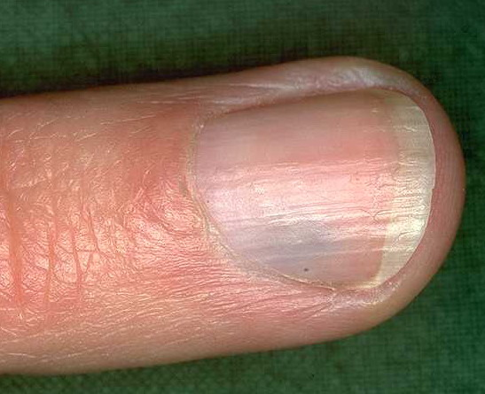

Your Diagnosis?

Diagnosis: Glomus Tumor

- History of hypersensitivity to cold in the left middle finger.
- There was small dark blue lesion at the proximal nail fold, on the left fifth digit.
- There were no nail changes.
- The Love’s test was positive and cold water increases the pain.
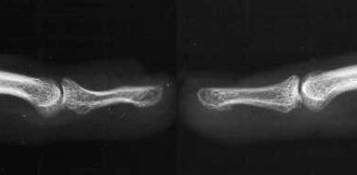

x-rays may show bone erosion of terminal
phalanx ('shell out' lesion

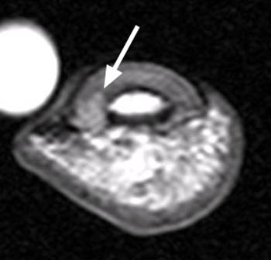

An MRI showed a isointense mass deep at the base of the nail bed.

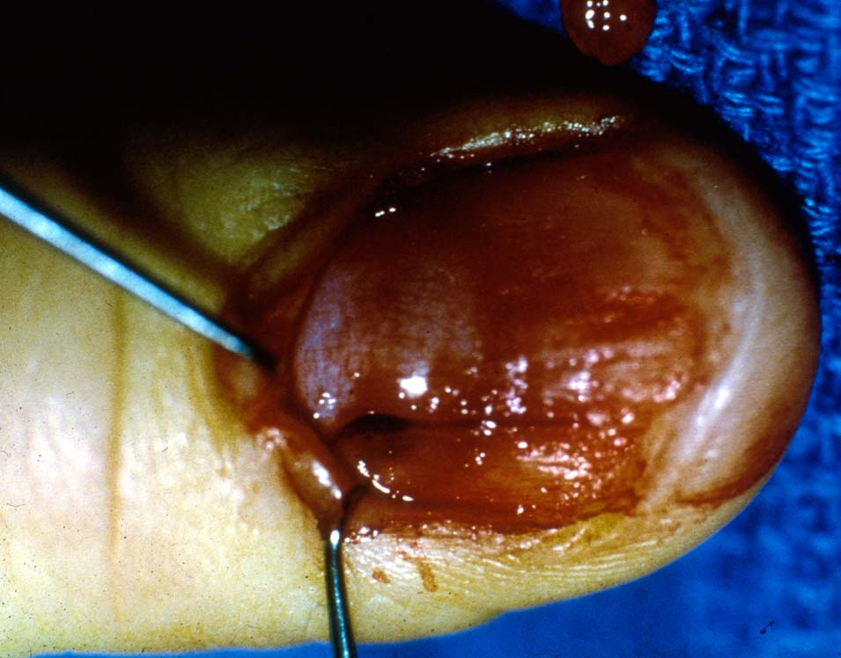
At surgery a freer elevator was used to remove the
nail from the nail bed of the right small finger.
A small, pigmented lesion was noted in the proximal aspect of the nail bed.
The thin, superficial layer of nail bed overlying the lesion was incised.
The tumor was easily shelled from the nail bed. The incised portion of the nail bed was loosely re-approximated with 6–0 chromic and the nail plate was replaced and suture in place.

Pathology
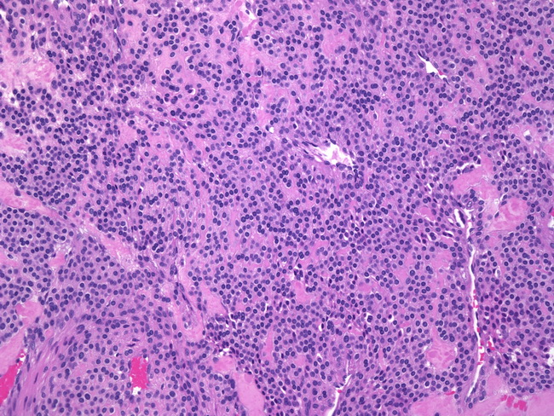
- The glomus body is an end organ arteriovenous
anastomosis composed of neuro-myo-arterial
tissue that is thought to regulate skin
temperature and circulation.
- The tumors are described as a deep red, blue, or
purple, encapsulated
- It is less than 1 cm in diameter
- They can occur in clusters, or can be isolated.
- Glomus tumor circumscribed nests of uniform cells adjacent to capillaries. Non-medullated nerve crossing through center.

Three years later, the patient is pain free, showing no signs of recurrence.

Discussion
In 1812, glomus tumors were first identified by Wood as a tumor of the subcutaneous tissue that was small, firm, painful, and sensitive to temperature change. Although glomus tumors can be found throughout the body, 75 % are found on the hand mainly
in a subungual location.

The prevalence is quoted as ranging from 1 to 4% of all tumors of the hand
88% were women with an average age of 44 years.
The diagnosis of a glomus tumor is based on the triad of symptoms: pain at rest, pain from direct pressure, and intolerance to temperature changes.

Provocation Signs:
1. Love’s pin test (direct pressure of a round pin head causing pain),
2. Hildreth’s test (applying a tourniquet to the base of the digit which decreases pain), 3. Cold sensitivity (placing the digit in cold water causing increased pain)

Due to the low prevalence of the tumor, the mean duration of diagnosis and
treatment is 5–10 years.
Although the diagnosis is based on clinical findings, an MRI is useful in identifying the exact location and size of a tumor
Treatment: recommended surgery based upon clinical findings, even if the MRI was negative.
Either: nail removal or a lateral approach
Most recently, Roan et al. have proposed a split nail technique of excision that
leaves the nail and nail bed intact. A small incision is made through the nail directly above the tumor and excision is performed. The nail is then closed with suture and the nail bed and cuticle are left untouched, resulting in an improved cosmetic result

D/D subungual lesion

1. Squamous cell Carcinoma:
SCC is the most common primary neoplasm of the hand and subungual area.
It accounts for approximately 90 % of all malignancies involving the hand.
In the subunqual region, SCC is a slow-growing tumor with a variable presentation. As a result, SCC is often misdiagnosed.
The time between the initial presentation and diagnosis averages 24–25 months.
It occurs more frequently in men after the fifth decade of life.
It is typically limited to a single digit involvement.
Potential etiologies include ultraviolet radiation, human papillomavirus infections, HIV and epidermal dysplasia
The presenting symptoms of SCC include pain, purulent drainage, bleeding, nail plate dyschromia, nail deformity, paronychia, and ulceration.
D/D: paronychial infections, chronic osteomyelitis of distal phalanx, pyogenic granuloma, primary syphilitic chancre, subungual hematoma, epidermoid cyst, subungual glomus tumor, enchondroma of distal phalanx, giant cell tumor, amelanotic melanoma, nevus, fibroma, metastatic tumors, and herpetic whitlow
Bony involvement and metastasis to regional lymph nodes may occur in 18%.
A definitive diagnosis of subungual SCC is made by biopsy.
Treatment options include limited or wide surgical excision, or amputation depending on the involvement of the soft tissue and underlying distal phalanx.

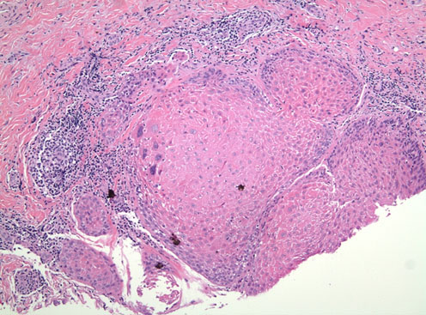

In small case series, radiation therapy as primary treatment was effective with low recurrence rates.

Subungual melanoma
Accounts for 1 to 3 % of all cutaneous melanoma in white patients
Up to 20 % of melanoma in individuals with highly pigmented skin.
The tumor most commonly presents on the thumb.
5-year survival ranges from 40 to 74 %.
The four types of melanoma include superficial spreading, nodular, lentigo maligna, and the least common, acral lentiginous. Acral lentiginous melanoma is the most prevalent in that location [50%].
These lesions can lack pigmentation and appear relatively benign.
The pigmentation of the surrounding nail tissue, called Hutchinson’s sign, paired
with nail lifting is indicative of melanoma.
The role of sentinel lymph node biopsy and elective lymph node dissection remains controversial.

Subungual Keratoacanthoma
Subungual keratoacanthoma is a benign neoplasm
It usually presents as a painful, rapidly growing lesion on the terminal phalanx, in
either a periungual or subungual location.
Subungual keratoacanthoma appears to be most common in middle age Caucasians with a slight predilection for men
Compared to squamous cell carcinoma patients, subungual keratoacanthoma patients are younger and the onset of symptoms is more rapid.
Sun exposure, tar, mineral oil, steel wool, and human papilloma virus have been suggested.
Rapid growth noticed within weeks of onset helps differentiate a keratoacanthoma from a SCC.
The treatment of subungual keratoacanthoma is surgical.

Onychomatricomaiˆ
Onychomatricoma is a rare fibro-epithelial nail bed tumor that usually affects middle-aged patients.
Onychomatricoma is the only known tumor to be formed from the nail matrix, thus producing primary nail deformity.
Treatment of onychomatricoma is surgical excision.

