FRACTURES OF THE LATERAL PROCESS OF THE TALUS

Dimon described the injury in 1961.
The term “snowboarder's fracture is commonly used.
Large lateral process fractures with extension into the subtalar joint may lead to subtalar pain, arthritis, and loss of motion.
The literature related to lateral process fractures emphasizes two key points: that the injuries are commonly misdiagnosed and that early treatment improves functional results.

Anatomy
The lateral process of the talus is a large, broad-based, wedges-shaped prominence of the talar body. The lateral process includes two articular surfaces. Dorsolaterally, it articulates with the fibula; inferomedially, the lateral process articulates with the anterior portion of the posterior facet of the calcaneus. The lateral talocalcaneal ligament originates from the tip of the lateral process.

Mechanism of Injury and Classification
It has been suggested that the fracture results from a combination of ankle inversion and dorsiflexion. However, in a cadaver study, Funk noted that eversion of a dorsiflexed and axially loaded ankle was more likely to result in a lateral process fracture.

Hawkins divided fractures of the lateral process into three groups: a nonarticular chip fracture, a single large fragment involving the talofibular and subtalar articulations, and a comminuted fracture involving both articulations. In some cases, the fracture may be associated with subtalar joint incongruity or have marked displacement.

Clinical and Radiographic Findings
May mimic those of an inversion ankle sprain. Swelling and ecchymosis are commonly localized to the lateral aspect of the ankle.
Point tenderness is localized to the lateral process, and most patients retain the ability to bear weight.
The diagnosis of lateral process fracture should be considered in patients with acute findings similar to an ankle sprain, patients previously diagnosed with an ankle sprain who do not appear to be recovering in the usual time course, and those who present with chronic lateral ankle pain.

Standard anteroposterior, lateral, and mortise radiographs are often insufficient to detect.
A CT scan is frequently necessary to fully understand the injury.
MRI will similarly detect and define fractures of the lateral process and associated injuries.
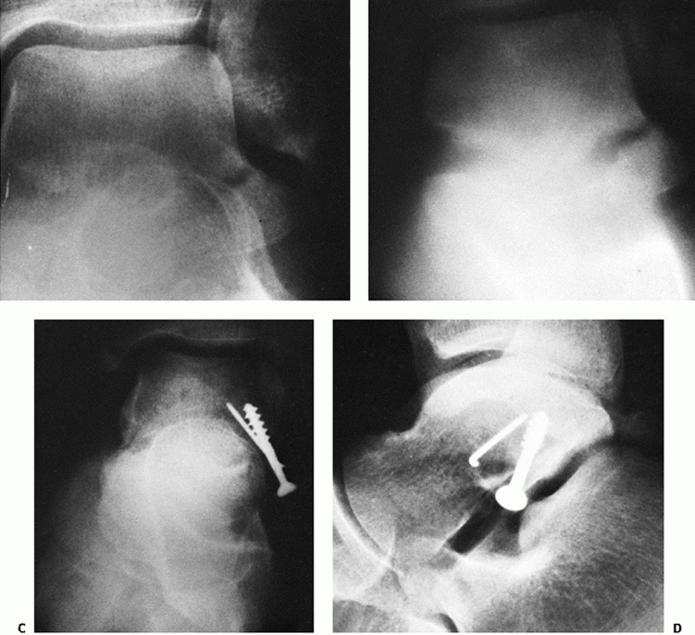

Type of lateral process fracture
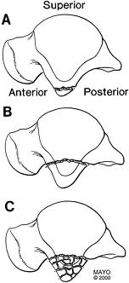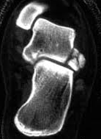

Treatment
Factors that determine appropriate treatment: include size of the fracture fragment, displacement of the fragment, and degree of communition, associated injuries, and joint congruity.
In general, small fracture fragments and undisplaced fractures are appropriately treated without surgery, with a period of immobilization.
Large fractures associated with significant displacement and involving substantial portions of the subtalar joint are treated with open reduction and internal fixation.

For comminuted fractures, primary excision of fragments is indicated to avoid the later development of arthritic changes in the subtalar joint. Excision of a 1-cm³ fragment should not cause ankle or subtalar instability.

Open reduction or fragment excision may be performed through a direct lateral approach using an incision over the sinus tarsi. When open reduction is performed, screw fixation can often be accomplished with the screw inserted fro
m the tip of the process and extending posteriorly and superiorly into the talar body. Screws ranging from 2.0 to 2.7 mm in diameter are typically sufficient for fixation of lateral process fractures.

Prognosis and Complications
Pain in the region of the subtalar joint seems to be common following fractures of the lateral process, in particular when the diagnosis is delayed.
Nonunion of unreduced fractures and residual malalignment of the subtalar joint cause persistent symptoms.
Earlier recognition of lateral process fractures may be leading to more favorable outcomes.
Degenerative changes were noted in the subtalar joint in several patients approximately 3 years after the injury.

The management and outcome of lateral process fracture of the talus.
Perera A, Baker JF, Lui DF, Stephens MM.
Foot Ankle Surg. 2010 Mar;16(1):15-20. Epub 2009 May 1. Review.
PMID: 20152749 [PubMed - indexed for MEDLINE]

Rev Chir Orthop Reparatrice Appar Mot. 2008 Dec;94(8):e1-7. Epub 2008 Oct 8.
Forty-four fractures in 43 patients were reviewed with a mean follow-up of 17 months. The diagnosis had been made immediately in 14 cases and secondarily in 30 cases with a delay of 46 months.
RESULTS:
14 cases of associated pseudarthrosis and subtalar osteoarthritis, two cases of isolated pseudarthrosis and two cases of isolated subtalar osteoarthritis.
In the immediate diagnosis group, five of 14 patients had at least one complication: 29% pseudarthrosis and 29% subtalar osteoarthritis. Excellent in 58%, good in 28%
Foot Ankle Surg. 2010 Mar;16(1):15-20. Epub 2009 May 1.
The management and outcome of lateral process fracture of the talus.
109 Cases in total were identified including four cases from a personal series. 50 Type I, 17 type II and 29 type III fractures were analysed. A significant number of patients required late surgery when the diagnosis was initially missed.
CONCLUSION:
Type I fractures are best treated with ORIF, type II with excision and type III with casting. Fractures presenting late that are not united should be excised if small and internally fixed if large.

